**Benefactory Shopify Integration**

**DEMO URL:** <https://shopifydemo.benefactory.in/>

**ADMIN URL:** <https://shopifydemo.benefactory.in/admin>

Username: priyanka@benefactory.in

Password: alternation

**STEP 1: Setup Contribution as a product in Shopify.**

* + Remember to keep tracking inventory as off. Set the amount which you provide us

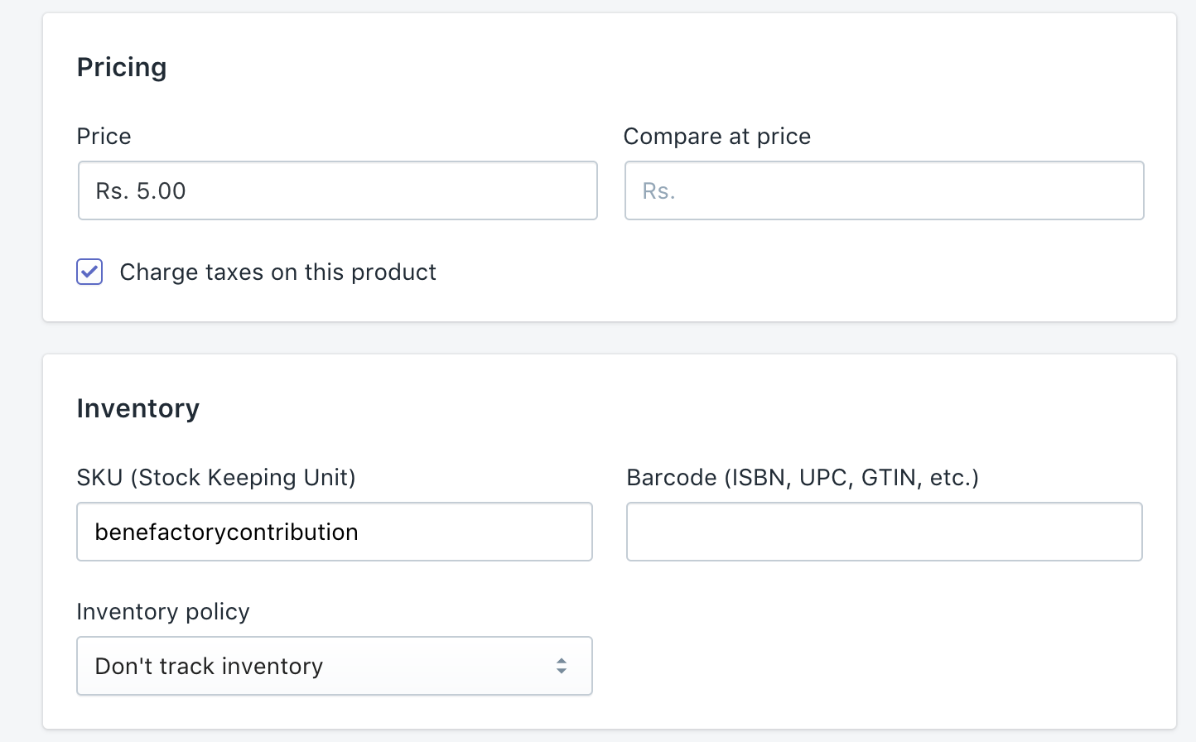

* Also Add Vendor Type as Benefactory

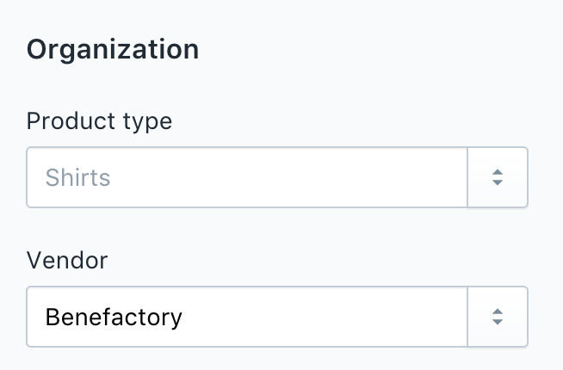

Then - Create a new Collection - called ‘All’. This will ensure that the benefactory product doesn’t show up in your catalog.

Make sure - it looks like the below:

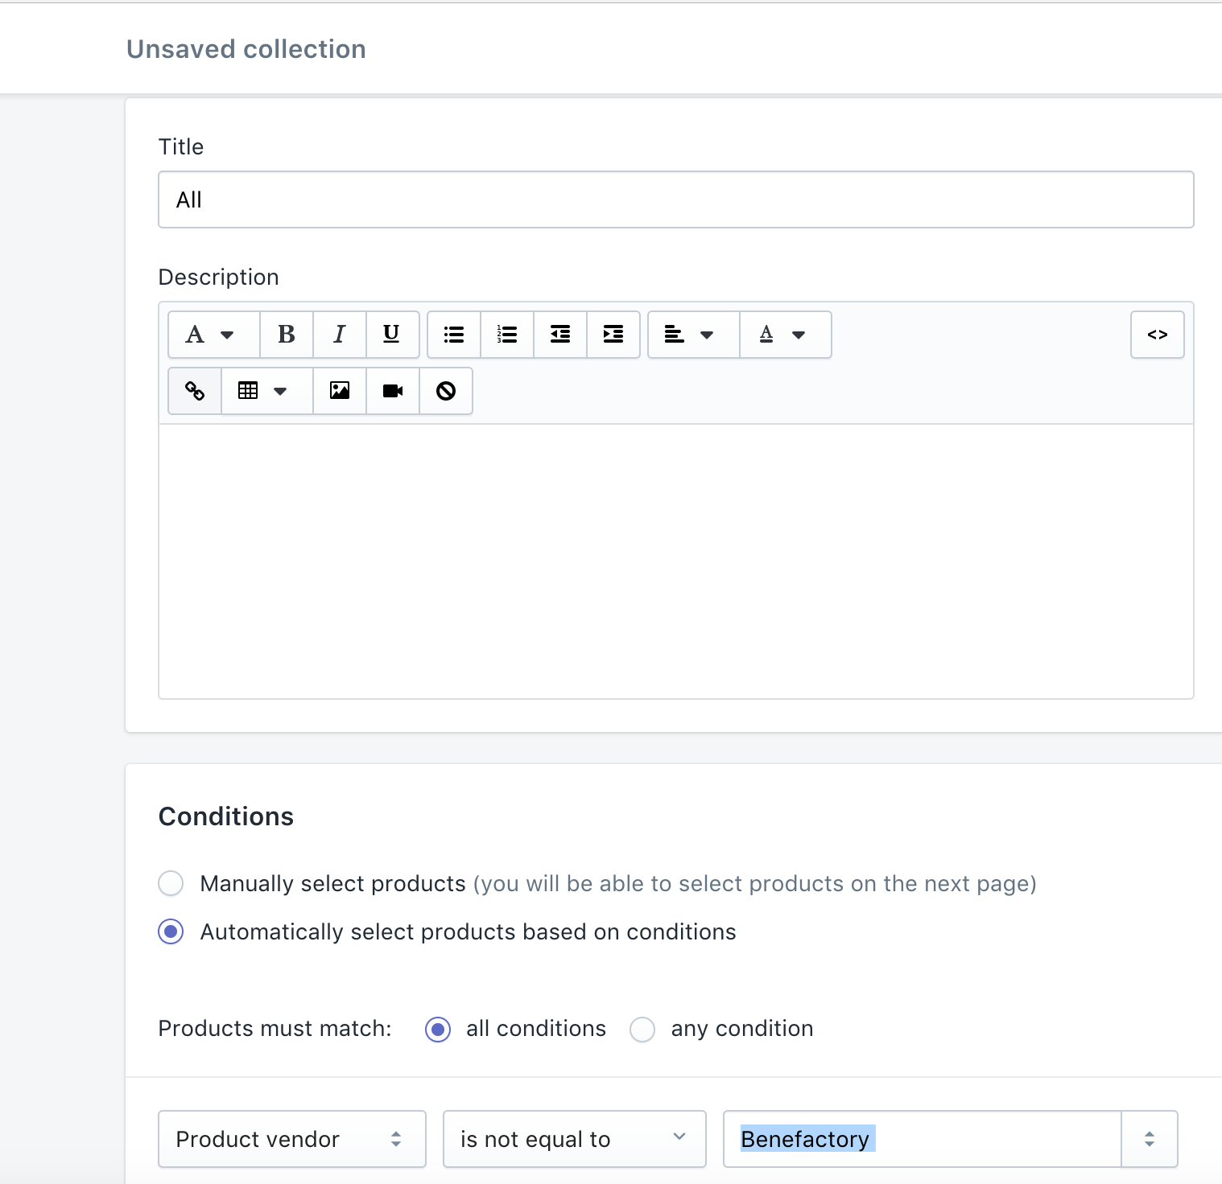

And Save it.

**STEP 2**: **Two lines of text for Checkbox - add this to your cart-template.liquid file (IF YOU DON’T HAVE ACCESS TO THE CODEBASE, FOLLOW THE STEPS AT THE END OF THIS DOCUMENT BEFORE PROCEEDING)**

**Add these lines to Layout > cart-template.liquid**

<input type="checkbox" id="bf_contribution" onclick="bf_contribution_add()" />

<label for="contribution">Contribute Rs. 5 to <a target="_blank" href="http://www.benefactory.in">Benefactory</a></label>

**STEP 3: Add this to your theme.liquid so the bf-shopify.js gets copied over**

<!--[if (gt IE 9)|!(IE)]><!--><script src="{{ 'bf-shopify.js' | asset_url }}" defer="defer"></script><!--<![endif]-->

<!--[if lte IE 9]><script src="{{ 'bf-shopify.js' | asset_url }}"></script><![endif]-->

and also add the bf-shopify.js file to your theme > assets folder and the bf-shopify.scss.liquid files to the assets folder

**STEP 4: Update the product Variant ID in the assets > bf-shopify.js file above**

* To get the Variant ID, Follow the steps here (<https://help.shopify.com/themes/customization/products/find-variant-id>)
  + Go to the contribution product in shopify admin panel and append .xml to the url. You’ll find the variant id there.

**STEP 5: (Optional) Hide the Remove Button for the contribution button in the cart**

**You can do this in layout > cart-template.liquid**

* To get the product id:
  + Go to the contribution product in shopify admin panel

Then write this code near the delete or remove button

{% if item.product_id != 11402984533 %}

{% end if %}

**STEP 6: (Required) Hide the Quantity Picker / Make it non-editable for the quantity picker.**

**You can do this in layout > cart-template.liquid**

* To get the product id:
  + Go to the contribution product in shopify admin panel

Then write this code near the quantity picker

{% if item.product_id != 11402984533 %}

{% end if %}

**STEP7: Go to Settings > Notifications and scroll to the bottom and add the following web hooks (scroll to the bottom of the page):**

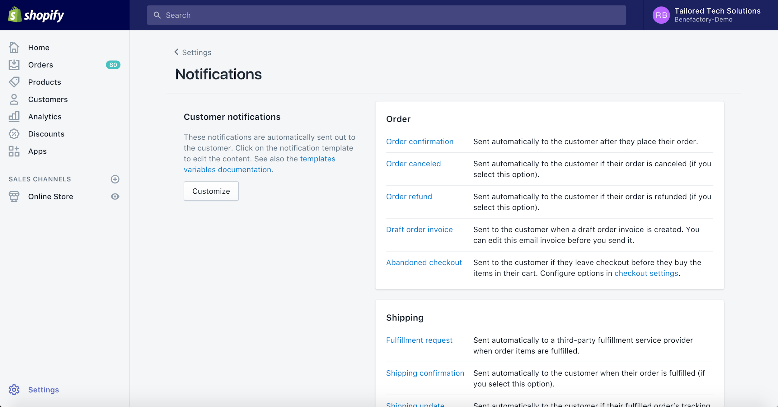

Order Creation

Order Payment

Order Cancellation

Order Update

URL: http://www.benefactory.in/api/v1/shopify_contribute?variant_id=48679630869&client_id=2&client_secret=EGp3dFcKJUSnCBCgWvpNjdXNVsfM5HXseAlO2HIo

(Please replace with the variant id from step 4 and the client id and secret given by Benefactory)

**STEP 8:** Go to Setting > Checkout (this will reset the pre-check at the cart for the benefactory contribution)

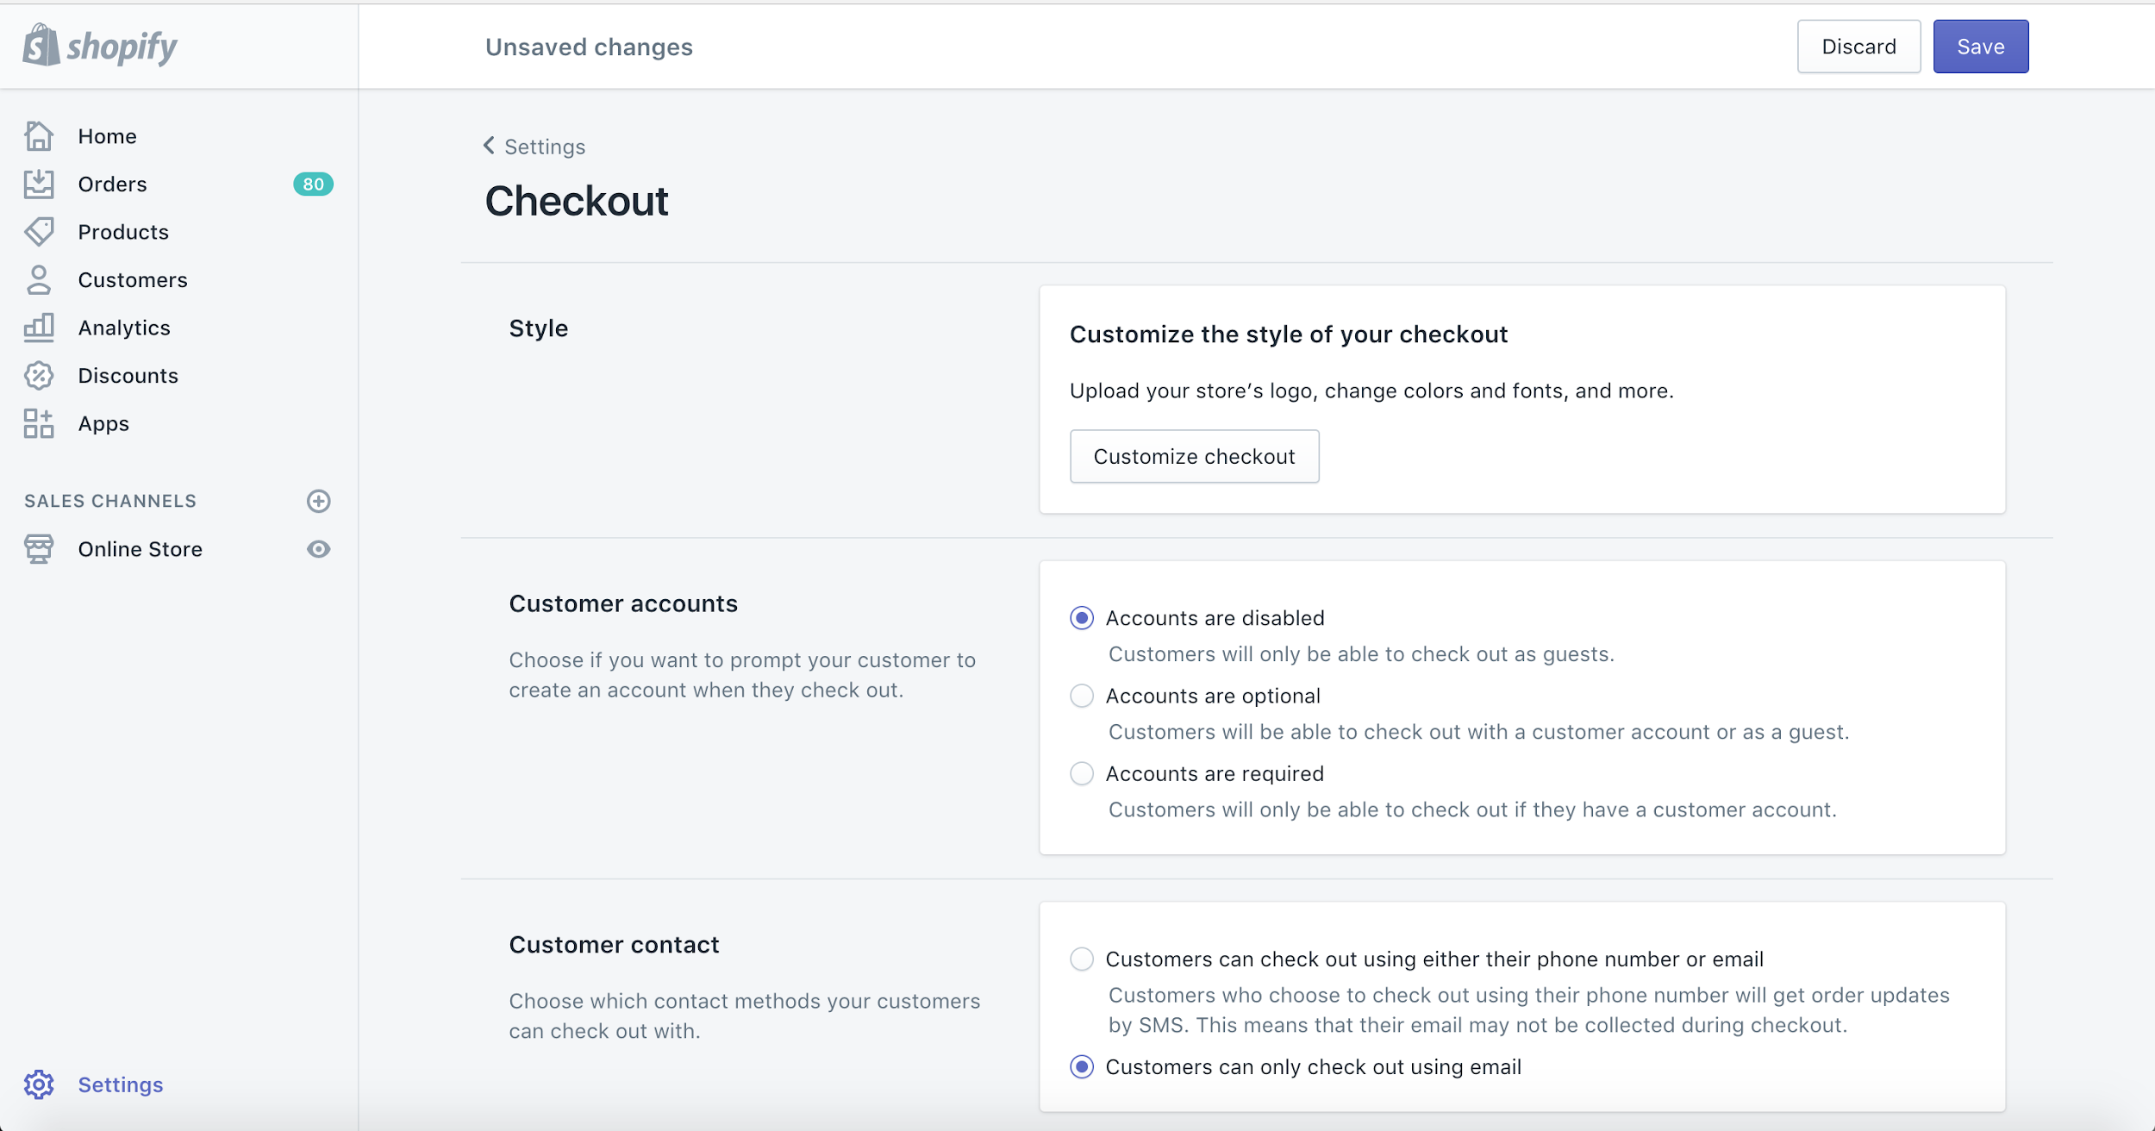

Scroll down to additional scripts

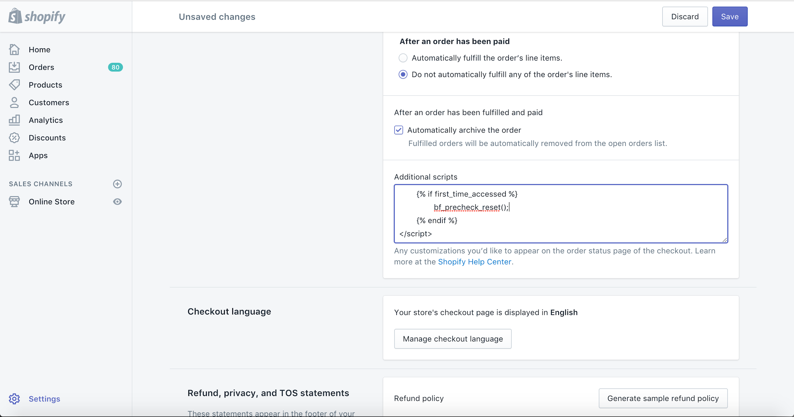

Copy the following lines to additional scrips and save it:

{{ 'bf-shopify.js' | asset_url | script_tag }}

<script>

{% if first_time_accessed %}

bf_precheck_reset();

{% endif %}

</script>

**STEP 9: Make sure you have a private app created so that the Ajax API can be accessed**

Apps > Manage Private Apps > Add a new App

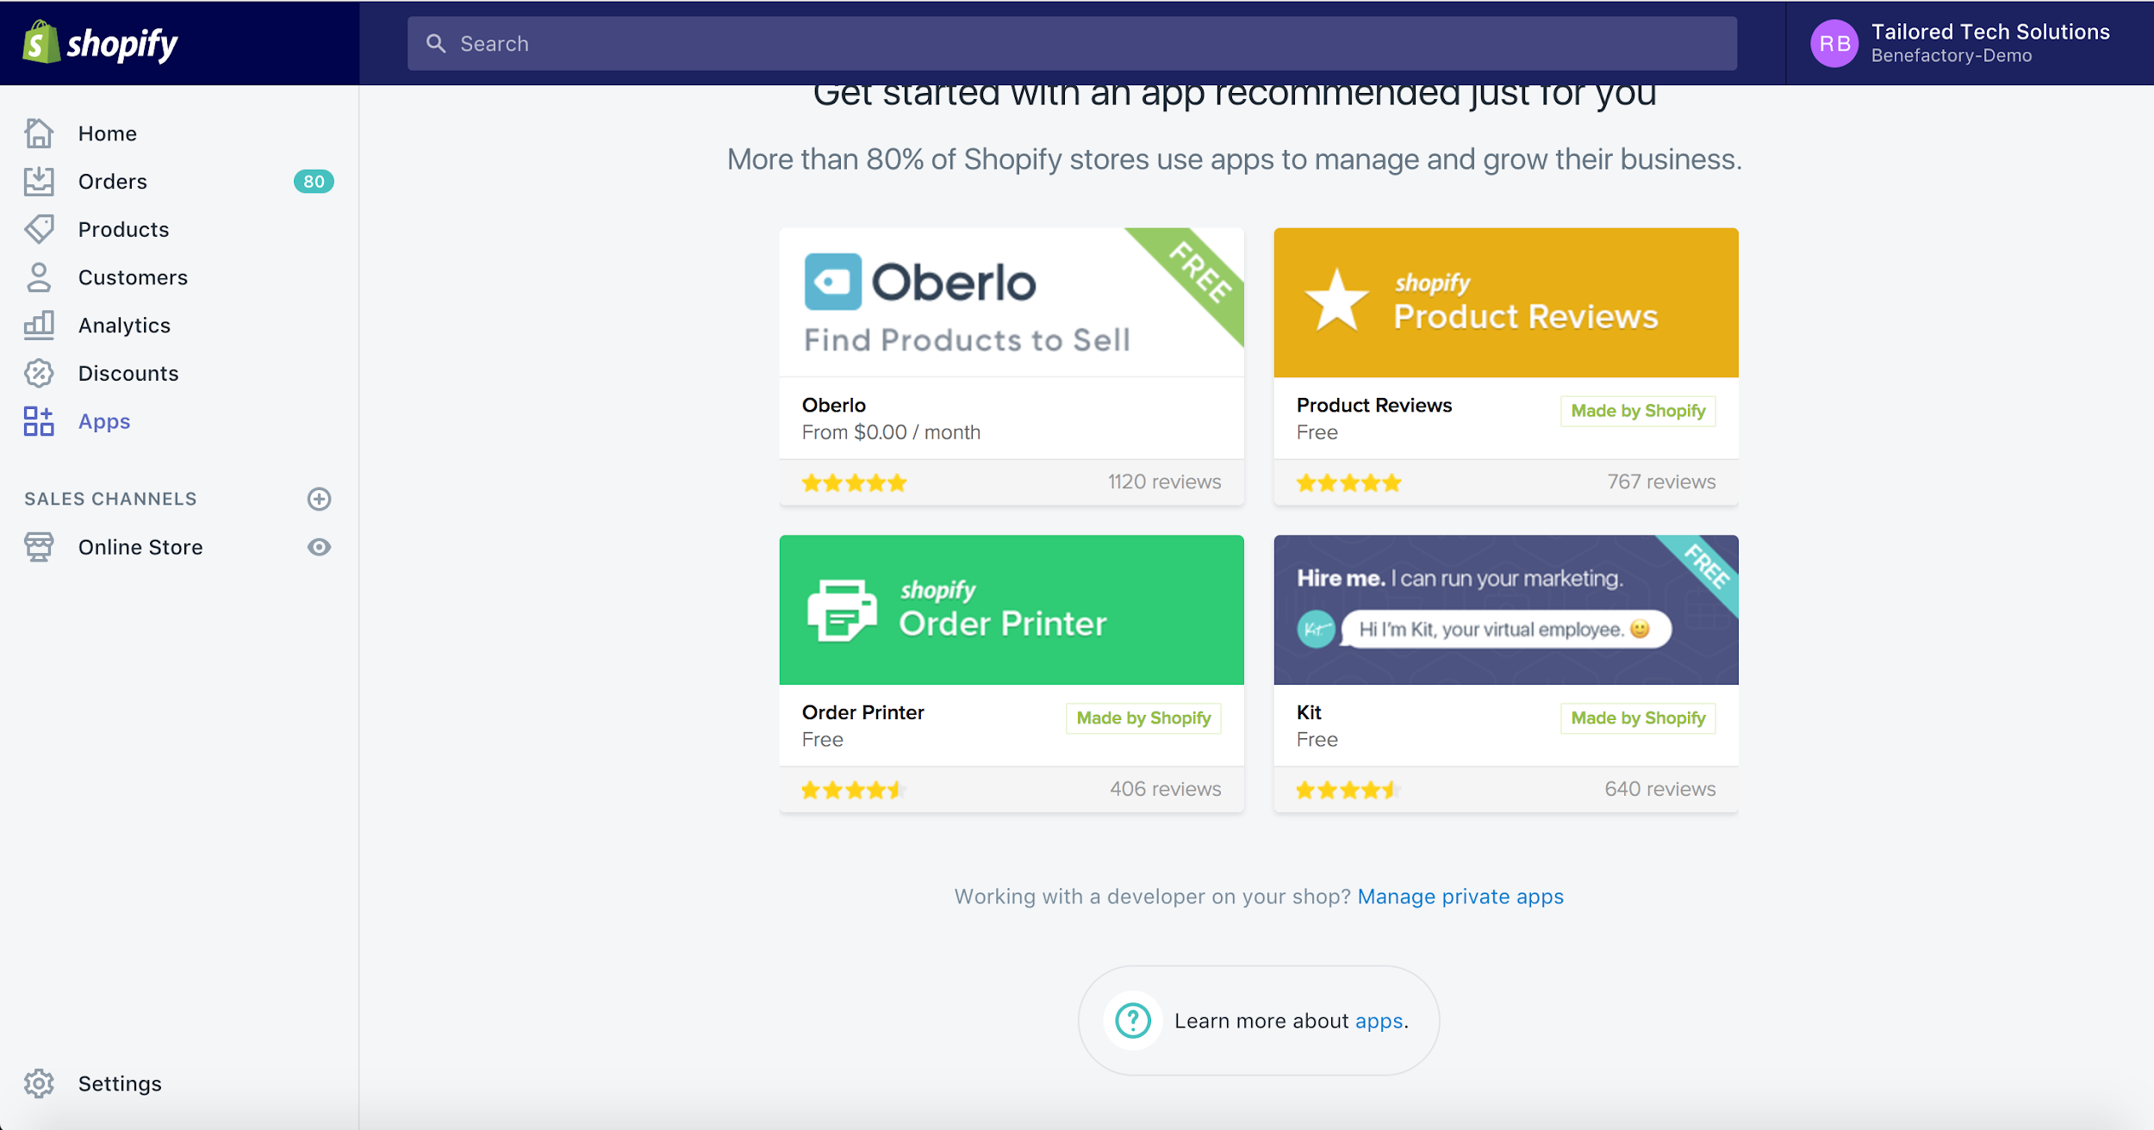

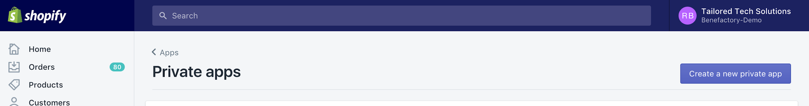

Just follow the steps

**If you don’t have access to the codebase - you can find the files below**

**STEP 1:** Click on online store and then themes. Select the customize button from your current theme

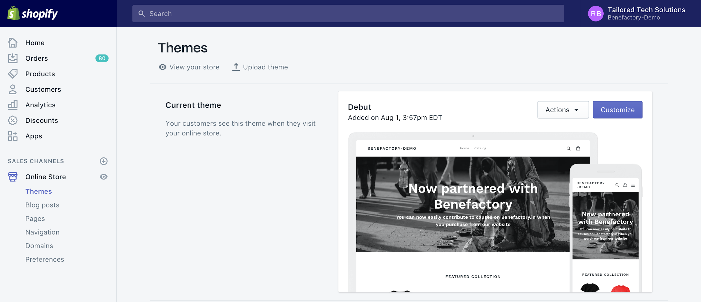

**STEP 2:** In the screen below - Click on More Actions and Edit Code



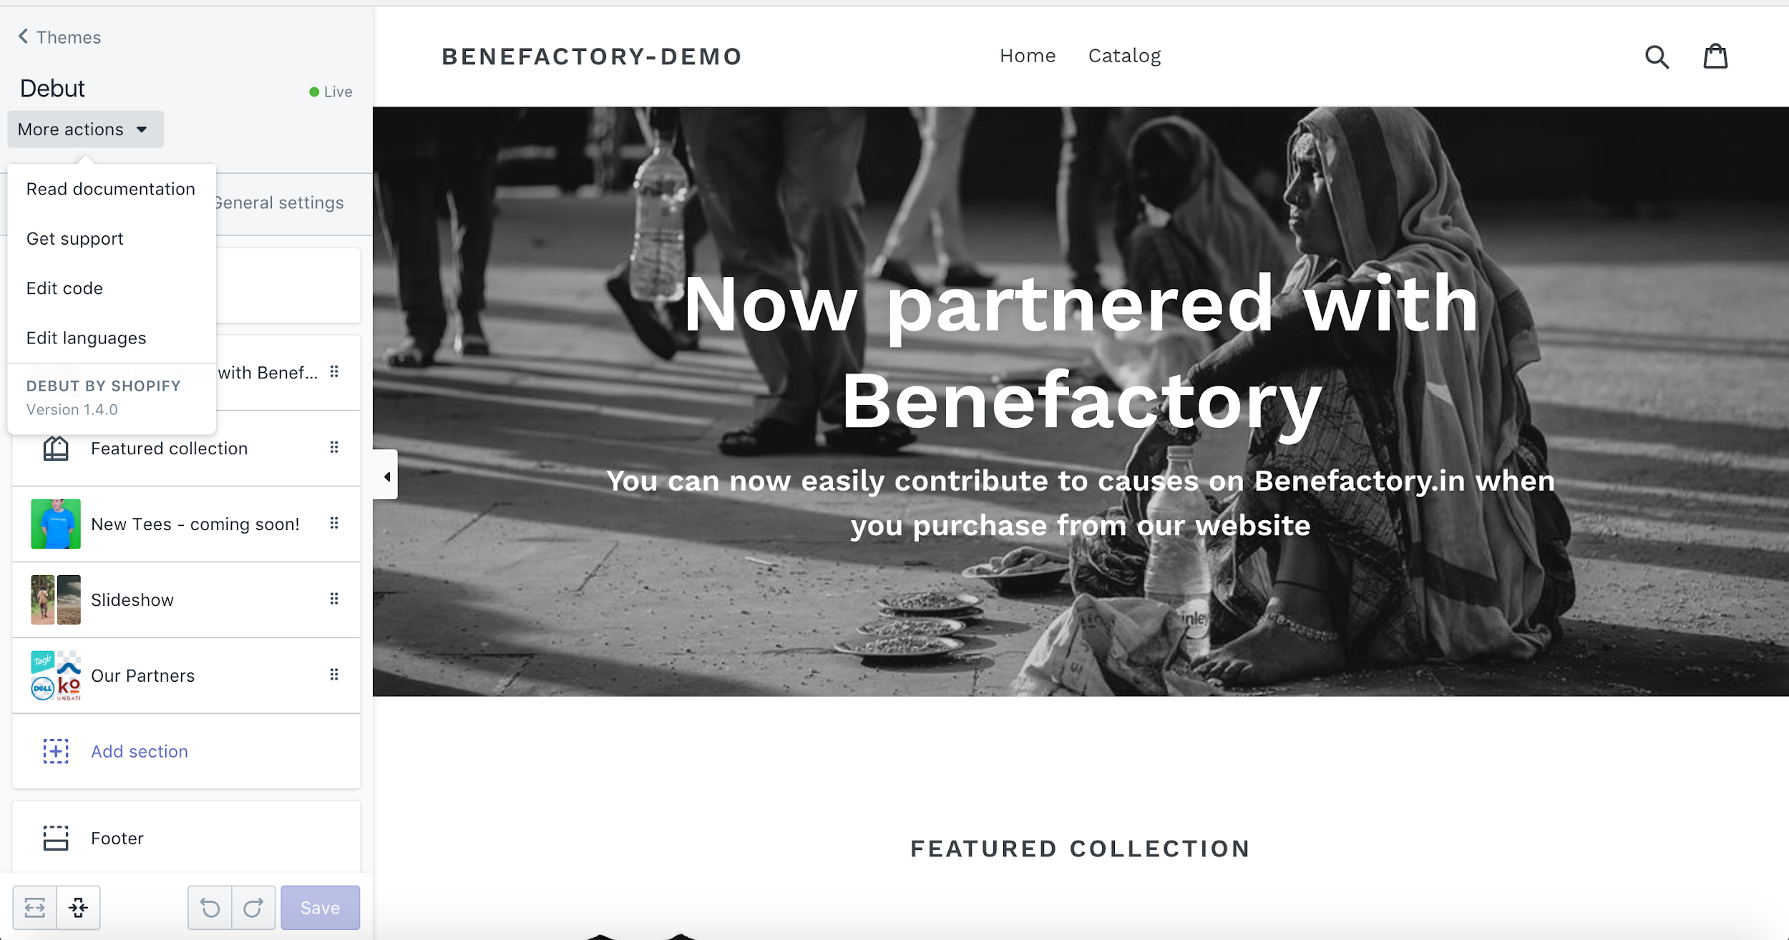

**Step 3:** Look for the same files as per the steps above and edit it. You can look at the file explorer below for reference

sections > cart-template.liquid

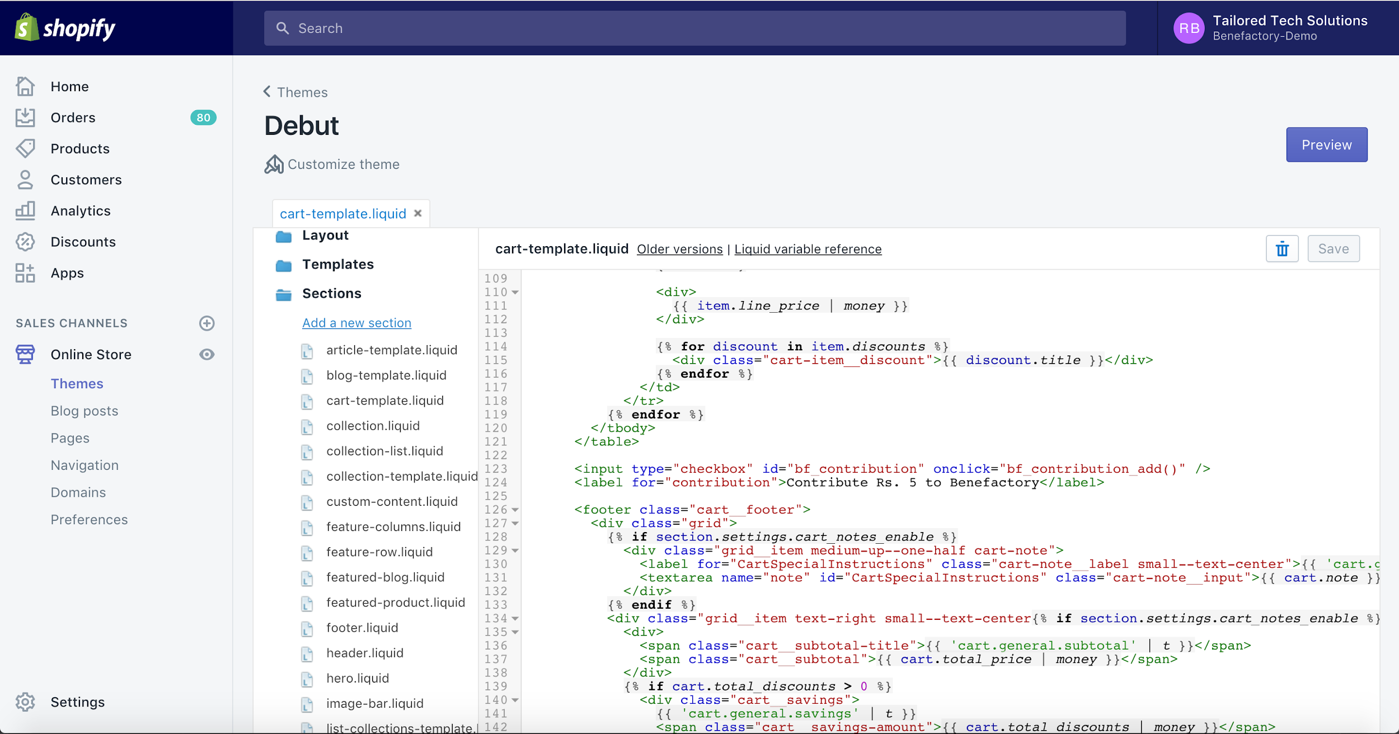

Layout > theme.liquid

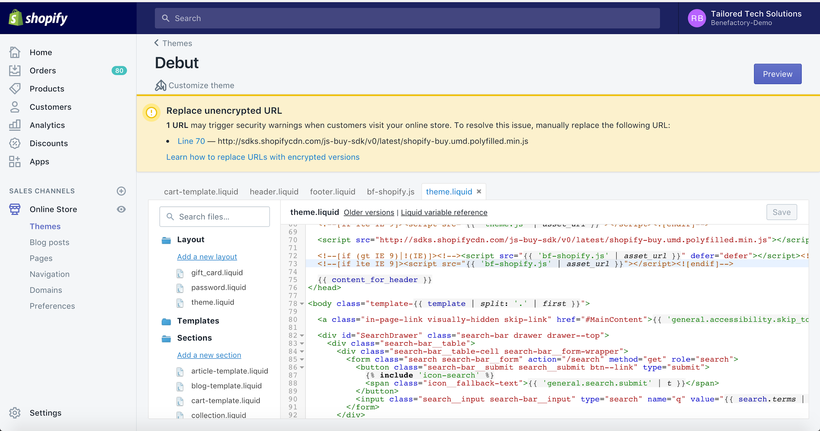

Go to Assets > and click on Add new Asset. Add the bf-shopify.js files and bf-shopify.scss.liquid files here. Then continue to follow the steps in the article.

